Software Requirements Specification (SRS)
Smart EV Charging Station Management System
1. Introduction
1.1 Purpose
The purpose of this document is to describe the functional and non-functional requirements of the Smart EV Charging Station Management System. This system provides an online platform for electric vehicle users to locate charging stations, book charging slots, and manage bookings efficiently.
1.2 Scope
The Smart EV Charging Station Management System is a web-based application that enables EV users to:
- Register and log in to the system
- Search for available charging stations
- View charging slot availability
- Book charging slots
- Generate QR codes for booking verification
- Cancel or manage bookings
The system also allows administrators and station staff to manage charging stations and monitor bookings.
1.3 Definitions and Abbreviations
Term | Meaning
EV | Electric Vehicle
SRS | Software Requirements Specification
API | Application Programming Interface
DB | Database
JWT | JSON Web Token
QR | Quick Response Code

2. Overall Description
2.1 Product Perspective
The Smart EV Charging Station Management System is a web-based application that follows a client-server architecture.
The system includes:
- Frontend: HTML, CSS, JavaScript
- Backend: Node.js with Express.js
- Database: MySQL
- Authentication: JWT
- Additional Feature: QR Code generation for booking verification
2.2 Product Functions
The main functions of the system include:
- User registration and authentication
- Viewing charging stations
- Viewing available charging slots
- Booking charging slots
- Generating QR code for booking
- Viewing booking history
- Cancelling bookings
- Admin monitoring of stations and bookings
2.3 User Classes and Characteristics
EV User
- Electric vehicle owner
- Registers and books charging slots
Admin
- Manages charging stations
- Monitors all bookings
Station Staff
- Manages slot availability
- Verifies QR codes during charging
2.4 Operating Environment
Component | Technology
Frontend | HTML, CSS, JavaScript
Backend | Node.js, Express.js
Database | MySQL
Browser | Chrome, Firefox, Edge
2.5 Design Constraints
- The system must use MySQL for data storage
- Authentication must be implemented using JWT
- The system must support web browsers

3. System Features
3.1 User Registration
Description
Allows users to create a new account.
Inputs
- Name
- Email
- Password
- Phone number
Output
User account successfully created.

3.2 User Login
Description
Users log in using email and password.
Input
- Email
- Password
Output
- Authentication token generated
- User logged in successfully

3.3 View Charging Stations
Description
Displays a list of available charging stations.
Input
User request to view stations
Output
List of stations with location and availability

3.4 View Available Slots
Description
Displays available charging slots for a selected station.
Input
Station ID
Output
List of available time slots

3.5 Book Charging Slot
Description
Allows users to reserve a charging slot.
Input
Slot ID
Output
Booking confirmation with QR code

3.6 Cancel Booking
Description
Users can cancel previously booked slots.
Input
Booking ID
Output
Booking cancelled successfully

3.7 View Booking History
Description
Displays all bookings made by the user.
Output
List of bookings with status and QR code

4. External Interface Requirements
4.1 User Interface
The system provides a web interface with pages for:
- Registration
- Login
- Station listing
- Slot booking
- Booking history
4.2 Hardware Interface
Users access the system using a computer or mobile device connected to the internet.
4.3 Software Interface
The system interacts with:
- MySQL Database
- Web Browser
- QR Code generation library

5. Non-Functional Requirements
5.1 Performance Requirements
The system should respond to user requests within 2 seconds under normal conditions.
5.2 Security Requirements
- User authentication using JWT
- Passwords stored securely
- Unauthorized access prevented
5.3 Reliability
The system should maintain data consistency during booking operations.
5.4 Usability
The system interface must be simple and easy to use.
5.5 Scalability
The system should support multiple users simultaneously.

6. System Architecture
The system follows a client-server architecture.
Components include:
- Client Browser
- Frontend Interface
- Backend Server
- REST API
- Business Logic Modules
- MySQL Database
Data flows from user interaction to backend services and database operations.

7. Database Requirements
The system database includes the following tables:
- Users
- Stations
- Slots
- Bookings
Relationships:
- A user can make multiple bookings
- A station can have multiple slots
- A booking references a user, station, and slot

8. Agile Development Approach
The project follows an Agile development methodology with iterative implementation.
Sprint Plan
Sprint | Module
Sprint 1 | Authentication Module
Sprint 2 | Station Management
Sprint 3 | Slot Management
Sprint 4 | Booking System
Sprint 5 | QR Code Integration
Sprint 6 | Frontend Integration and Testing

9. Assumptions and Dependencies
- Users have internet access
- Charging stations maintain accurate slot availability
- Database server is available continuously

10. Future Enhancements
Possible future improvements include:
- Mobile application support
- Real-time slot availability tracking
- Payment integration
- Charging analytics dashboard

DATA FLOW DIAGRAM

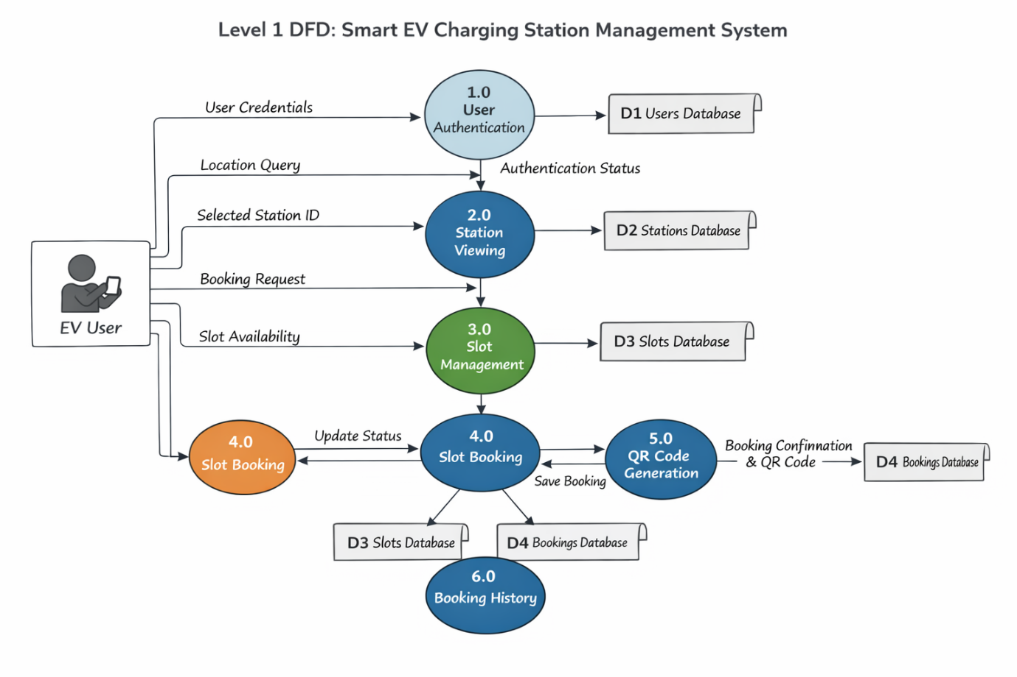

ER DIAGRAM
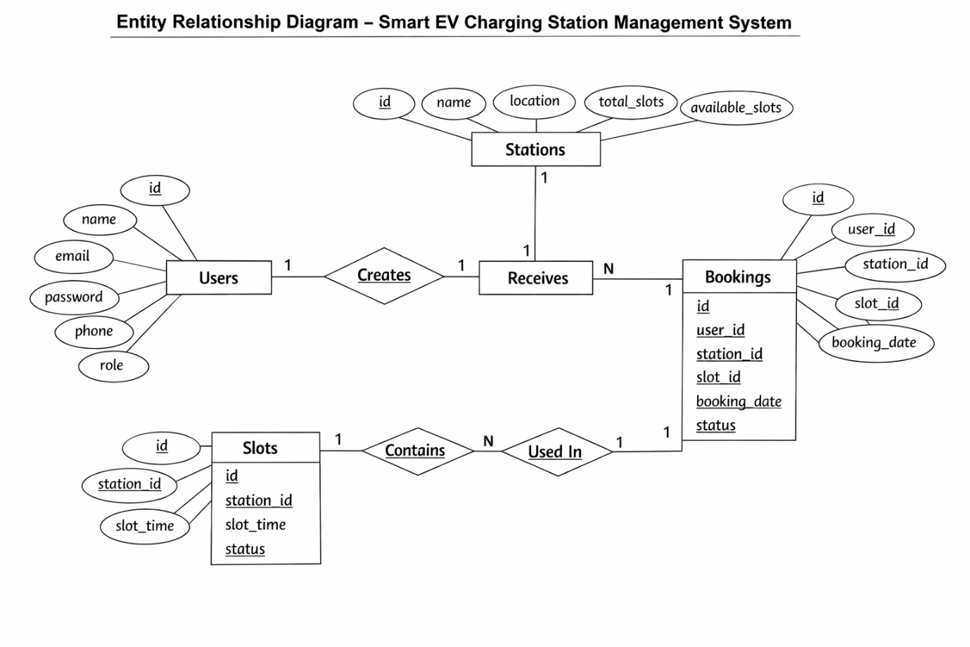
SYSTEM ARCHITECTURE DIAGRAM
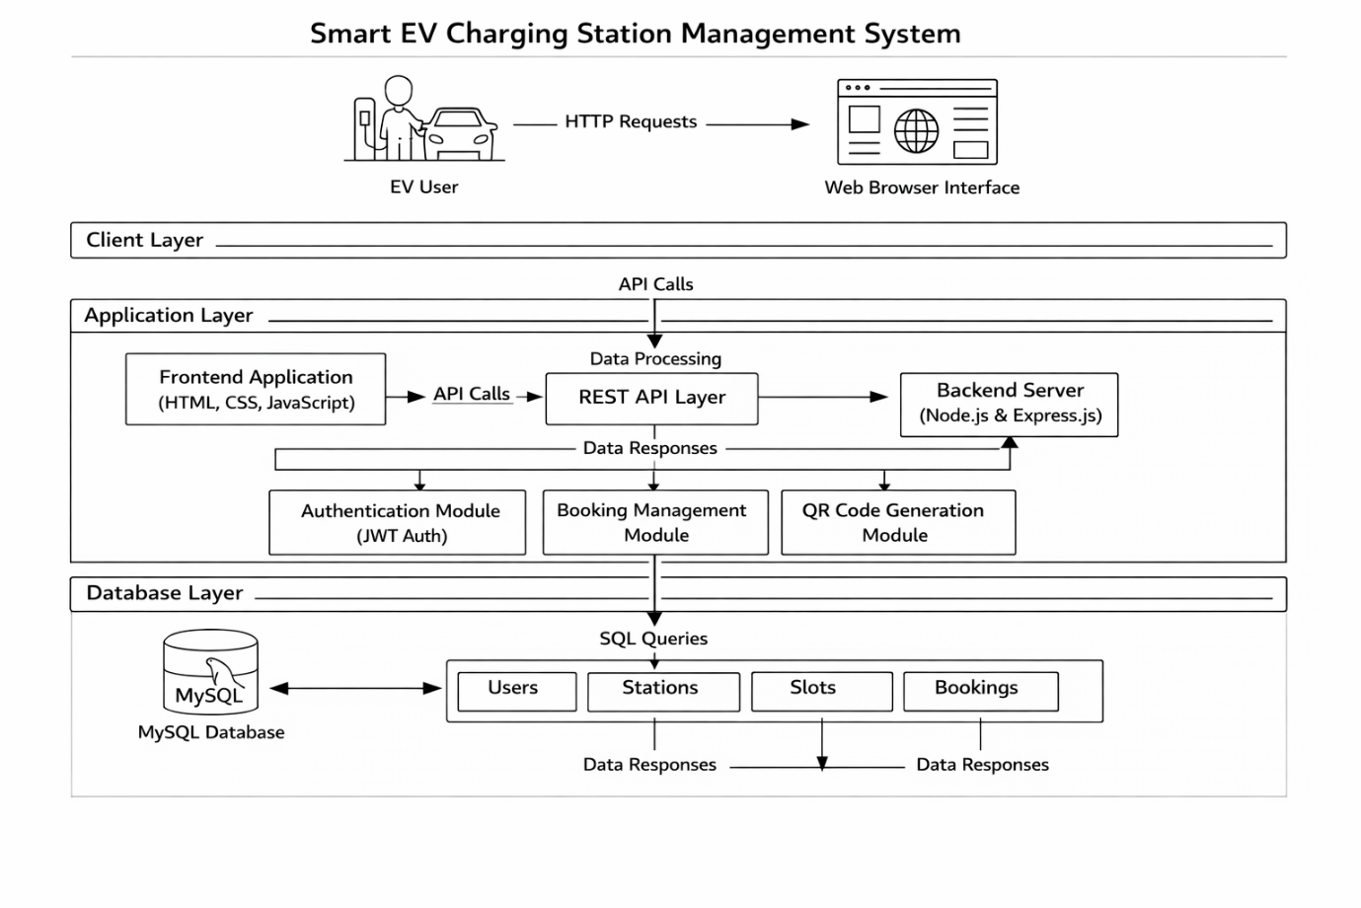
UML - USE CASE DIAGRAM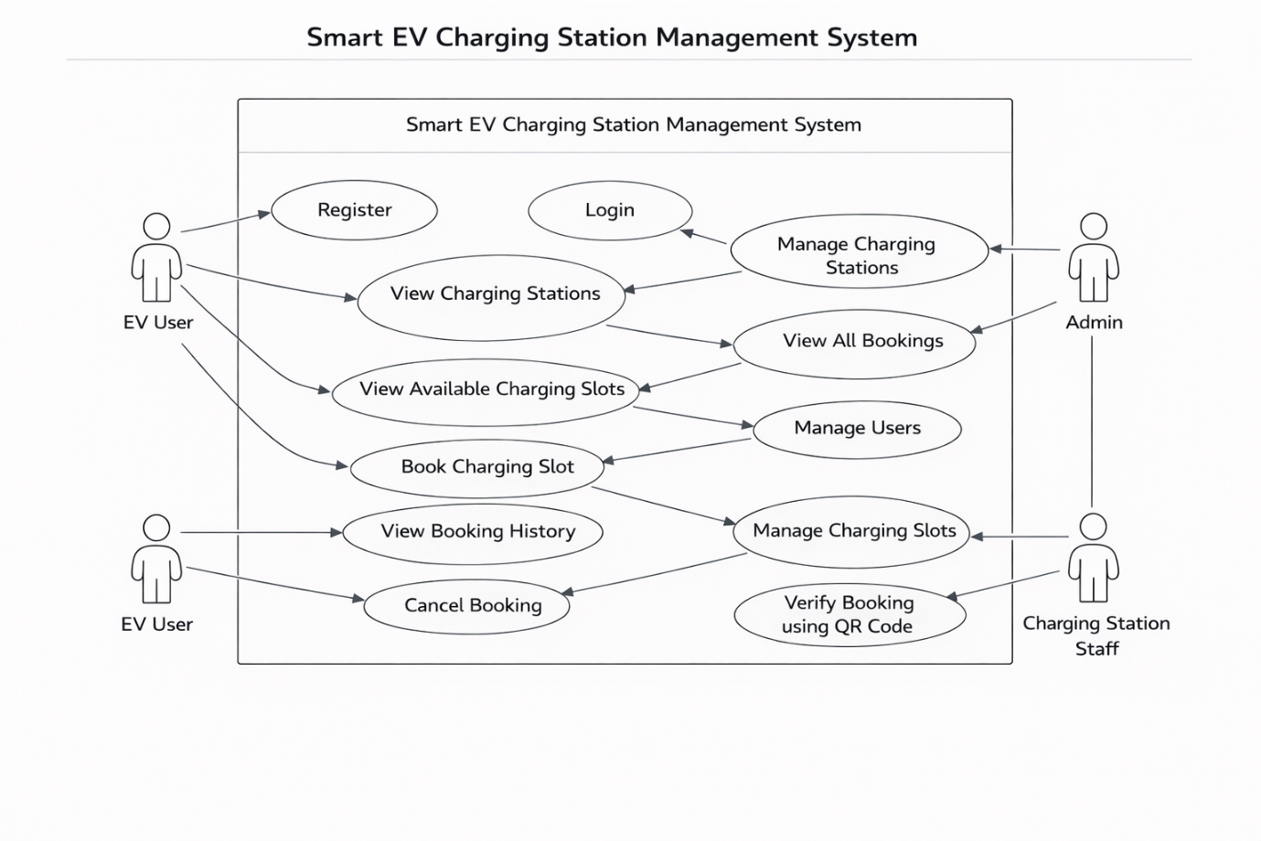
UML (SEQUENCE DIAGRAM)
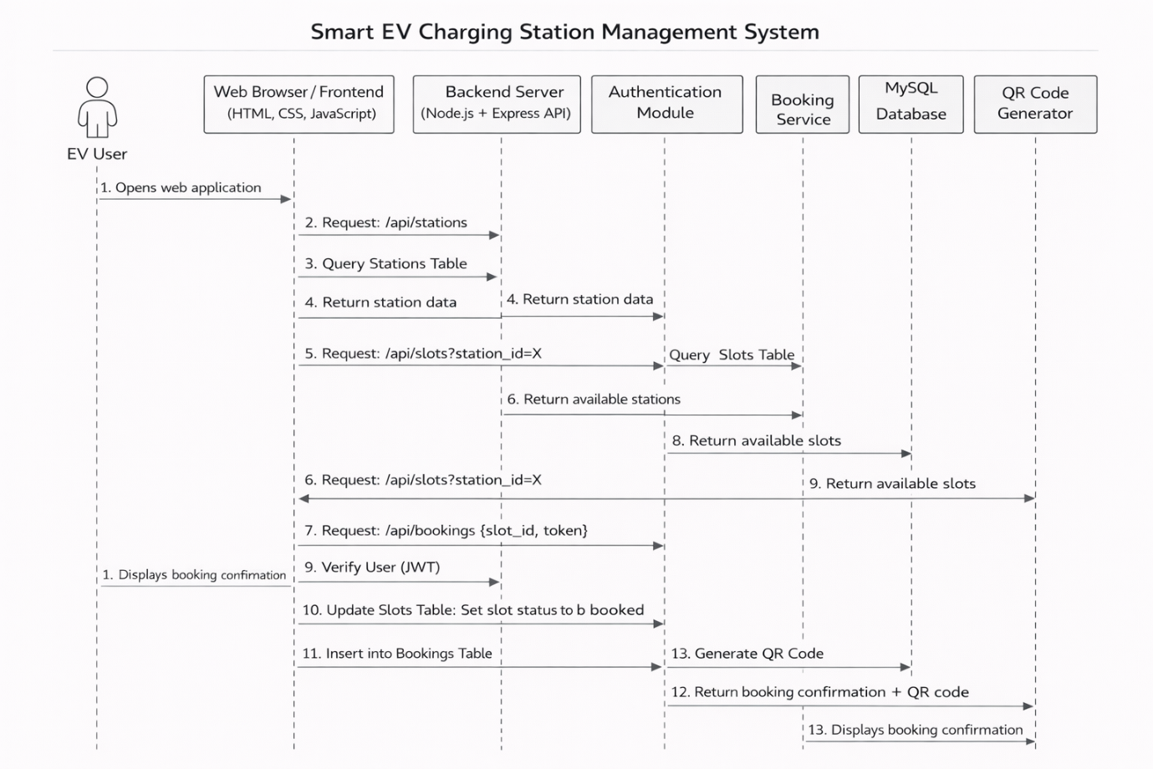

Module-wise Description

The Smart EV Charging Station Management System is divided into several functional modules. Each module is responsible for a specific set of operations within the system.

-User Authentication Module
Description

This module handles user registration, login, and authentication. It ensures that only registered users can access the system’s booking features.

Main Functions

- User Registration

- User Login

- Password validation

- JWT Token generation

- Secure session management

Technologies Used

- Node.js

- Express.js

- JWT Authentication

- MySQL database

Input

- User name

- Email

- Password

- Phone number

Output

- User account creation confirmation

- Authentication token for session access

- Charging Station Module
Description

This module manages information related to charging stations available in the system.

Main Functions

- View available charging stations

- Display station details

- Provide station location and slot availability

Data Stored

- Station ID

- Station name

- Location

- Available slots

Output

- A list of charging stations available to users.

- Slot Management Module
Description

This module manages charging time slots for each station.

Main Functions

- Create charging slots

- Display available slots

- Update slot availability

- Manage slot status (available/booked)

Data Stored

- Slot ID

- Station ID

- Slot time

- Slot status

Output

- List of available charging slots for selected stations.

6.4 Booking Module
Description

This module allows users to reserve charging slots and manage their bookings.

Main Functions

- Book charging slot

- Store booking details

- View booking history

- Cancel booking

Data Stored

- Booking ID

- User ID

- Station ID

- Slot ID

- Booking date

- Booking status

Output

- Booking confirmation and booking details.

- QR Code Generation Module
Description

This module generates QR codes for booking verification. The QR code contains booking information that can be verified by station staff.

Main Functions

- Generate QR code for each booking

- Encode booking information

- Display QR code to user

Technologies Used

- QR code generation library

Output

- QR code image associated with the booking.

- Admin Management Module
Description

This module allows administrators to monitor and manage system data.

Main Functions

- Manage charging stations

- Monitor user bookings

- Manage users

- View system activity

Output

- Administrative control panel for system monitoring.

Implementation Progress

The development of the Smart EV Charging Station Management System follows an Agile methodology with incremental implementation across multiple modules.

- Completed Modules
Module | Status | Description
User Registration | Completed | Users can create new accounts
User Login | Completed | Secure authentication using JWT
Charging Station Listing | Completed | Users can view available stations
Slot Viewing | Completed | Users can see available charging slots
Booking System | Completed | Users can reserve charging slots
QR Code Generation | Completed | QR code generated for booking verification
Booking History | Completed | Users can view their past bookings
Booking Cancellation | Completed | Users can cancel existing bookings

- Modules Under Development

Module | Status | Description
Admin Dashboard | In Progress | Interface for managing stations and bookings
Staff Module | In Progress | Station staff verification of bookings
System Analytics | Planned | Display charging usage statistics

- Development Milestones

The project development followed multiple iterative sprints.

Sprint Development Activity
Sprint 1 - Authentication module development
Sprint 2 - Charging station module implementation
Sprint 3 -Slot management system development
Sprint 4 -Booking system implementation
Sprint 5 -QR code integration
Sprint 6 -Frontend integration and testing

- Current System Status

- The system currently supports:

- User registration and login

- Viewing charging stations

- Viewing available charging slots

- Booking charging slots

- QR code generation for bookings

- Viewing booking history

- Cancelling bookings

The backend APIs are functional and integrated with the MySQL database, and the frontend interface allows users to interact with the system through a web browser.

Testing Plan
The testing plan for the Smart EV Charging Station Management System ensures that all modules of the system work correctly and meet the specified functional requirements. Testing focuses on verifying the core functionalities such as user authentication, station viewing, slot management, booking operations, and QR code generation.
The testing process includes the following stages:
- Unit Testing: Each module (authentication, station management, slot management, booking system) is tested individually.
- Integration Testing: Ensures proper interaction between frontend, backend APIs, and the MySQL database.
- System Testing: Tests the entire system workflow including user registration, login, slot booking, QR code generation, and booking cancellation.
- User Acceptance Testing: Confirms that the system meets user requirements and provides the expected functionality.
The testing environment includes a web browser (Google Chrome/Edge), Node.js backend server, MySQL database, and the frontend interface built using HTML, CSS, and JavaScript.

Test Cases
Test Case ID | Test Scenario | Input | Expected Result
TC01 | User Registration | Valid user details (name, email, password, phone) | User account is successfully created
TC02 | User Login | Correct email and password | User login successful and authentication token generated
TC03 | Invalid Login | Incorrect password | Error message displayed
TC04 | View Charging Stations | Request station list | List of charging stations displayed
TC05 | View Available Slots | Station ID | Available charging slots displayed
TC06 | Book Charging Slot | Valid slot ID | Slot booking created successfully
TC07 | QR Code Generation | Successful booking | QR code generated and displayed
TC08 | View Booking History | Logged-in user request | List of user bookings displayed
TC09 | Cancel Booking | Valid booking ID | Booking status updated to cancelled
TC10 | Unauthorized Access | Access system without login | Access denied message displayed

